Using a turbulence sphere, pressure data was collected along with current readings from the wind tunnel transducer. The data from all sessions was included in the calculation of turbulence factor and percent turbulence of NCSU’s subsonic wind tunnel.

Both of Wednesday’s sessions, in addition to Thursday’s second run, were missing the initial data point corresponding to the pressure reading of 0.5 psf. To counteract this anomaly, the data point from Tuesday’s first session was included as a data point in those three instances. Another anomaly in the data set can be noted as the first data point of Wednesday’s first run, which is due to an unusually high current reading of 4.634 mA, while the other sessions read the current to be around 4.5 mA. This anomaly was left in place in the data set and can be seen clearly in FIGURE.

From lab one, the calibration of the wind tunnel pressure transducer can be modelled by the curve ___EQUATION NUMBER_________. This calibration curve was used to find the pressure difference over the sphere by plugging in the recorded current values from the transducer. To find the pressure coefficient, these data points for differential pressure were divided by the corresponding recorded data points for the pressure in the wind tunnel.

Velocity was calculated first using EQUATION, and then Reynolds number was calculated using THIS EQUATION. Plotting the calculated coefficient of pressure values against Reynolds number yields FIGURE.

Interpolating between points on the graph, the Reynolds number for the wind tunnel related to the critical pressure coefficient, 1.22, is found to be 3.0374e5. The turbulence factor (TF) is then calculated using EQUATION, which then results in a TF of 1.2675 for the wind tunnel.

From the given experimental data in Fig. 3 (INSERT FIG 3 GIVEN) from the lab handout, another interpolation calculation from starting point (1, 0) to ending point (1.5, 6), where the x-values are the TF and the y-values are the percent turbulence, the resultant turbulence percentage for the wind tunnel is 0.3210%.

$$TF=\frac{3.85 x {10}^{5}}{Re}$$

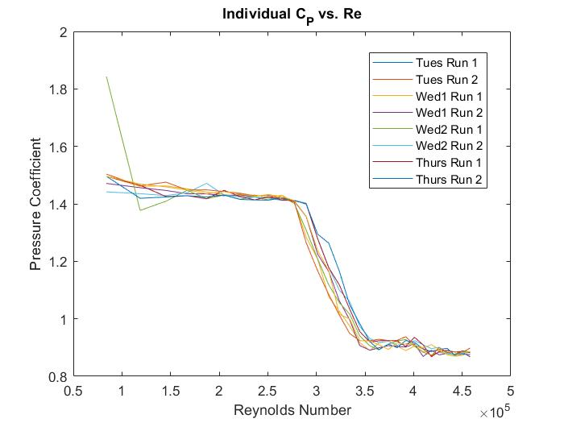

Figure 1. Individual pressure coefficient vs. Reynolds number. *Displays each of the experimental trails for the entire week. Note the clear discrepancy in the data in the first point from Wednesday session two’s first run.*

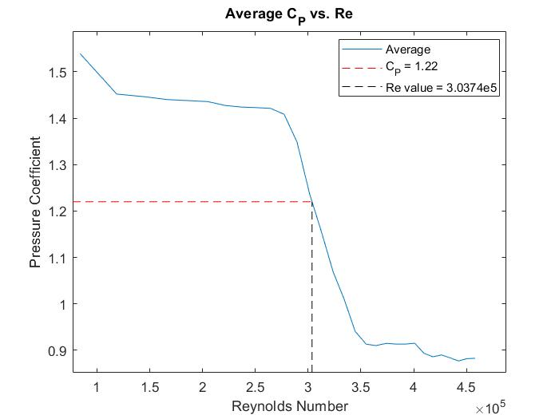

Figure 2. Magnetization as a function of applied field. *Figure captions should be bold and justified, with a period and a single tab (no hyphen or other character) between the figure number and the figure description.*

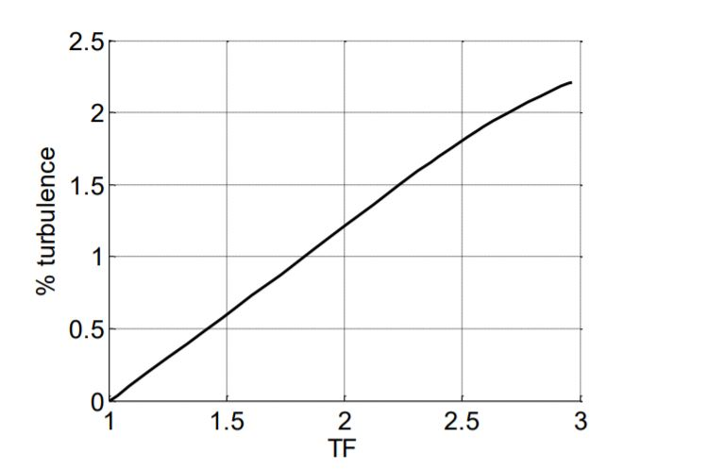

Figure 3. Variation of turbulence factor with per cent turbulence. *Figure captions should be bold and justified, with a period and a single tab (no hyphen or other character) between the figure number and the figure description.*